MENU

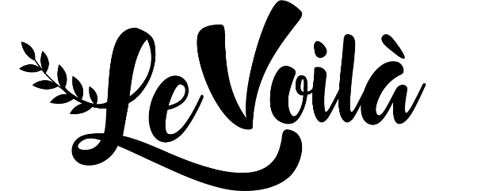We work mostly with **local** and **fresh** products. This means occasionally some products are not available. In this case we will provide an alternative.

**Do you have food allergies or special needs ? Please let us know.**

**PLATS**

Beef skewer with grilled vegetables, horseradish & herb sauce & fries – 18.50  
*Lalande de Pomerol – 4.50 (glass)*

***

Beer braised chicken stew with fries – 16.50  
*La Redoutable (local beer) – 8.20 (75cl)*

***

Tuna steak with green beans, grilled bell pepper, saffron butter & fries – 21  
*Sauvignon Blanc – 3.60 (glass)*

***

Teriyaki vegetable stir fry with noodles, cashew nuts & coriander – 13.50

**POUR LES PETITS**

Chicken nuggets & fries – 5.75

***

ice cream (various flavors)  
1 scoop – 1.50  
2 scoops – 3.00  
3 scoops – 4.50

**DESSERTS**

Blueberry trifle with orange, mascarpone & Grand Marnier – 7.50

***

Eton Mess – 6.50

***

Peach crumble with thyme, almonds & vanilla ice cream – 5.50

*Caliciae (local elderflower wine that goes well with all desserts) – 5.20 (glass)*



[Deze foto](http://www.pngall.com/bottles) van Onbekende auteur is gelicentieerd onder [CC BY-NC](https://creativecommons.org/licenses/by-nc/3.0/)

**FROMAGES**

3 local cheeses from Ferme Ligny in Melin – 7,50  
*Tawny Port – 3.60 (glass)*

**ENTRÉES**

Fresh melon soup with serrano ham, white port and basil – 6.50

***

Italian Vitello Tonnato; sliced veal in tuna sauce – 10.50  
*Bourgogne Pinot Noir – 3.90 (glass)*

***

Salad with pancetta, fresh figs, caramelized red onion, pecan nuts & blue cheese (also available without pancetta  ) – 8.50   
*Lalande de Pomerol – 4.50 (glass)*

***

Tomato tartlet with goat’s cheese, pine nuts and balsamic creme - 7.50